Steps of Action Potential to release of neurotransmitters:

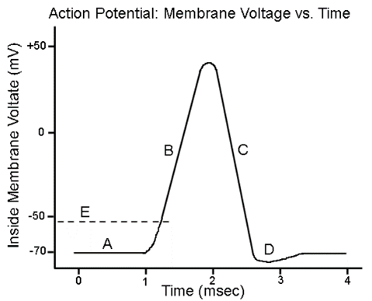
1. Threshold Starts the Process! (-55 Mv)
2. Voltage gated sodium channels open at -55mV
3. Sodium (higher in concentration outside the neuron) moves through the open channels by passive transport. (High to low concentration)
4. Adding positive charge to the neuron = depolarization (become more positive) all the way to +30
5. At +30 -> 1. Sodium channels close- Sodium is now stuck inside the cell and 2. voltage gated potassium channels open.
6. Potassium (Higher in concentration inside the neuron) moves passively out of the cell
7. Positive charge leaving the neuron = becomes more negative = repolarization
8. Repolarization continues to -70 mV
9. Voltage gated potassium channels close slowly allowing additional release of potassium out of the neuron, causing the voltage to “overshoot” the resting membrane potential of -70 = Hyperpolarization. Potassium is now stuck outside of the neuron.
10. The sodium Potassium pump (active transport- uses ATP) moves the ions back to where they started. It uses the energy of ATP to move 3 sodium ions back out of the cell and 2 potassium ions back in.
11. The action potential starts at the axon hillock and travels down the axon to the axon terminals.
12. At the axon terminals, voltage gated calcium channels open
13. Calcium flows into the axon terminals.
14. This triggers the release of the neuron’s neurotransmitters into the synapse between it and a 2nd nerve cell (by exocytosis)
15. Neurotransmitters move across synapse and begin binding to the chemically gated ion channels on the dendrites of the new neuron (This is starting the graded potential)
16. Within a few milliseconds, the neurotransmitters will stop binding the chemically gated channels and either be broken down or reabsorbed into the original neuron axon terminals.

The graded potential

1.

